**Project 1**

**Extra credit (Make 2 images with captions side by side)**

**Problem 1**

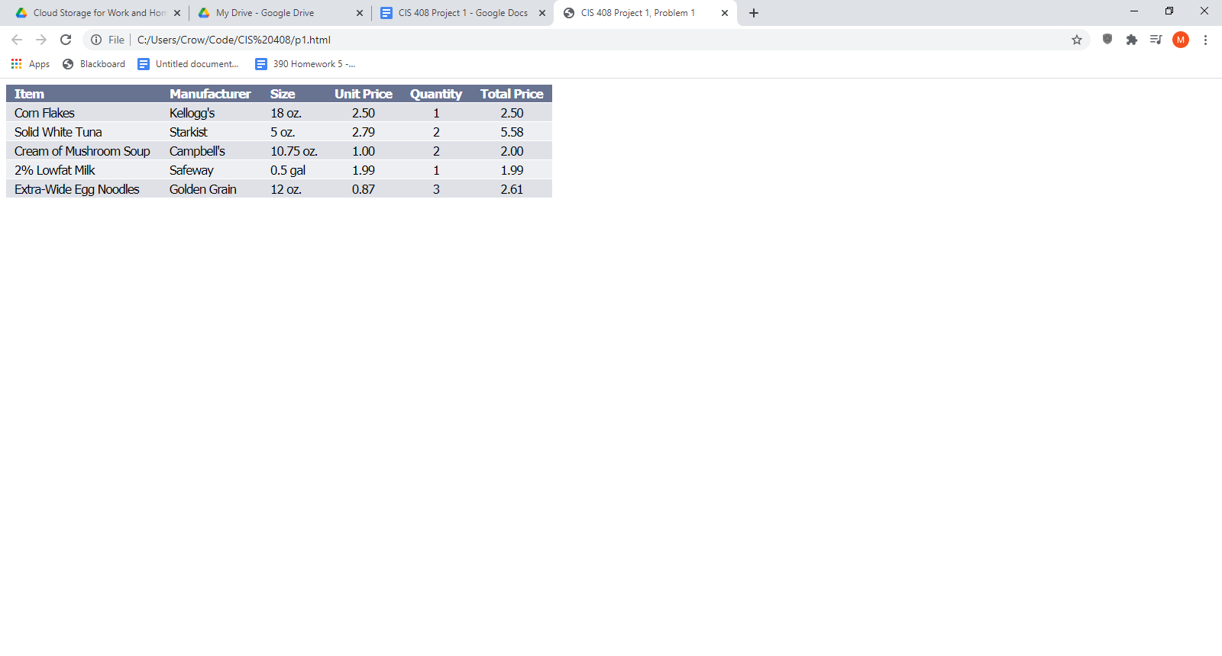

A version

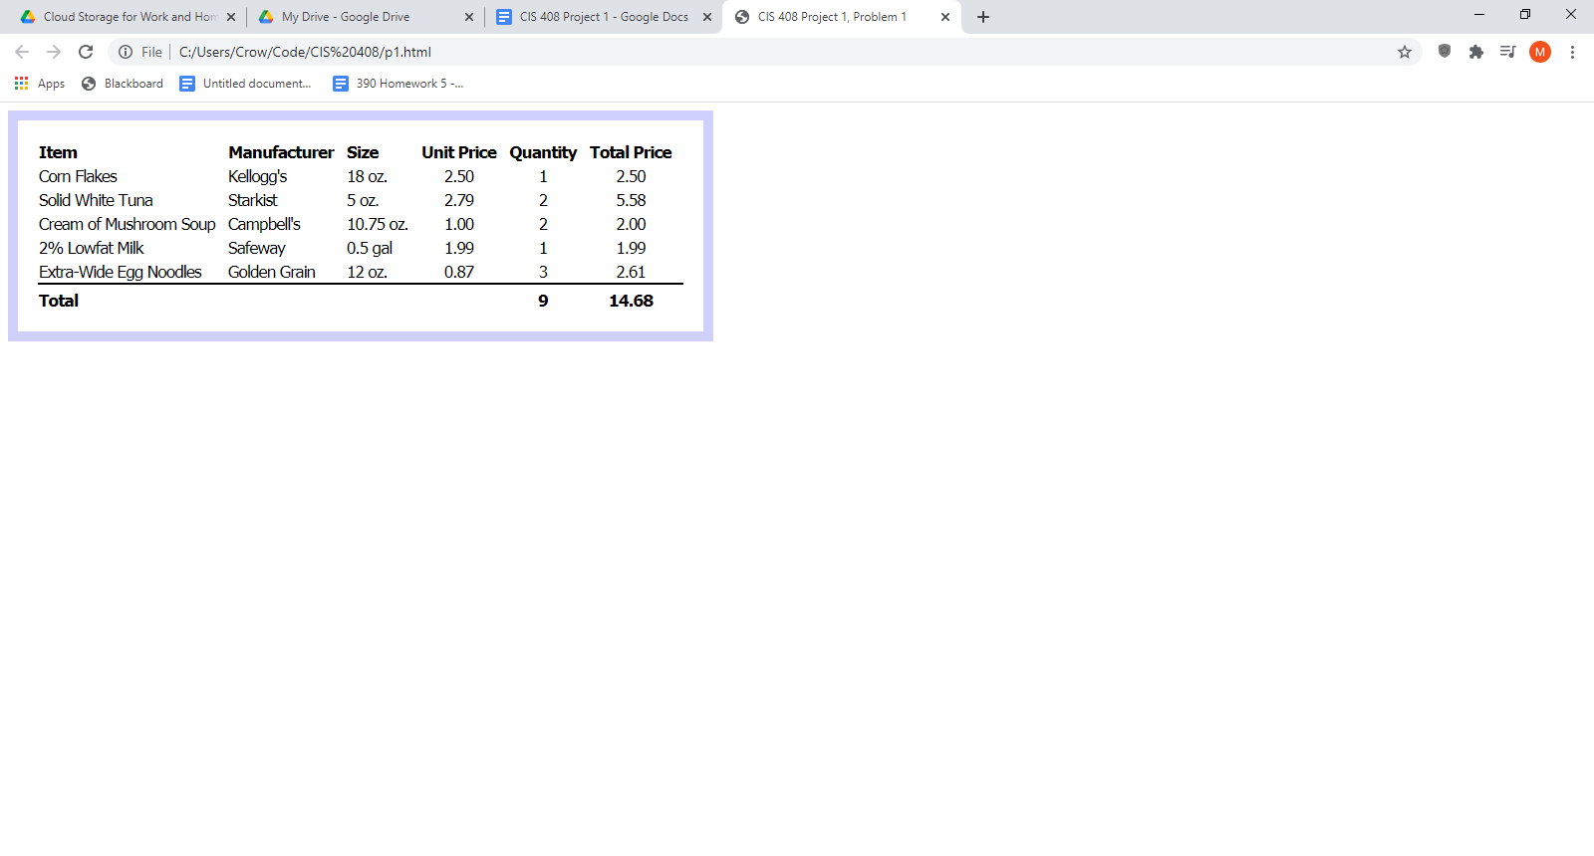

B version

**p1.html**

<?xml version="1.0" encoding="UTF-8"?>

<!DOCTYPE html PUBLIC "-//W3C//DTD XHTML 1.1//EN"

"http://www.w3.org/TR/xhtml11/DTD/xhtml11.dtd">

<html xmlns="http://www.w3.org/1999/xhtml">

<head>

<link rel="stylesheet" type="text/css" href="p1b.css" />

<title>CIS 408 Project 1, Problem 1</title>

</head>

<body>

<table cellspacing="0">

<tr>

<th>Item</th>

<th>Manufacturer</th>

<th>Size</th>

<th>Unit Price</th>

<th>Quantity</th>

<th>Total Price</th>

</tr>

<tr>

<td>Corn Flakes</td>

<td>Kellogg's</td>

<td>18 oz.</td>

<td>2.50</td>

<td>1</td>

<td>2.50</td>

</tr>

<tr>

<td>Solid White Tuna</td>

<td>Starkist</td>

<td>5 oz.</td>

<td>2.79</td>

<td>2</td>

<td>5.58</td>

</tr>

<tr>

<td>Cream of Mushroom Soup</td>

<td>Campbell's</td>

<td>10.75 oz.</td>

<td>1.00</td>

<td>2</td>

<td>2.00</td>

</tr>

<tr>

<td>2% Lowfat Milk</td>

<td>Safeway</td>

<td>0.5 gal</td>

<td>1.99</td>

<td>1</td>

<td>1.99</td>

</tr>

<tr>

<td>Extra-Wide Egg Noodles</td>

<td>Golden Grain</td>

<td>12 oz.</td>

<td>0.87</td>

<td>3</td>

<td>2.61</td>

</tr>

<tr class="hide">

<td>Total</td>

<td></td>

<td></td>

<td></td>

<td>9</td>

<td>14.68</td>

</tr>

</table>

</body>

</html>

**p1a.css**

body {

font-family: Tahoma;

font-size: 13pt;

letter-spacing: -1px;

}

td, th {

border-bottom: 1px solid white;

}

th {

background-color: #687291;

color: white;

}

th:nth-child(-n+3), td:nth-child(-n+3) {

text-align: left;

padding-right: 15px;

padding-left: 11px;

}

th:nth-child(3), td:nth-child(3) {

padding-right: 10px;

}

th:nth-child(n+4), td:nth-child(n+4) {

text-align: left;

padding-right: 12px;

padding-left: 12px;

}

tr:nth-child(odd) {

background-color: #eeeff2;

}

tr:nth-child(even) {

background-color: #dfe1e7;

}

td {

padding-top: 2px;

}

td:nth-child(n+4) {

text-align: center;

}

.hide {display: none}

**p1b.css**

body {

font-family: Tahoma;

font-size: 13pt;

letter-spacing: -1px;

}

table {

border: 10px solid #d0d0ff;

padding: 20px;

}

th:nth-child(-n+3), td:nth-child(-n+3) {

text-align: left;

padding-right: 12px;

}

th:nth-child(n+4), td:nth-child(n+4) {

text-align: center;

padding-right: 12px;

}

td {

padding-top: 2px

}

tr:nth-last-child(2) td {

border-bottom: 2px solid black;

}

tr:last-child td {

font-weight: bold ;

padding-top: 5px

}

**You need to change the href to get the other css layout**

**Problem 2 (extra credit)**

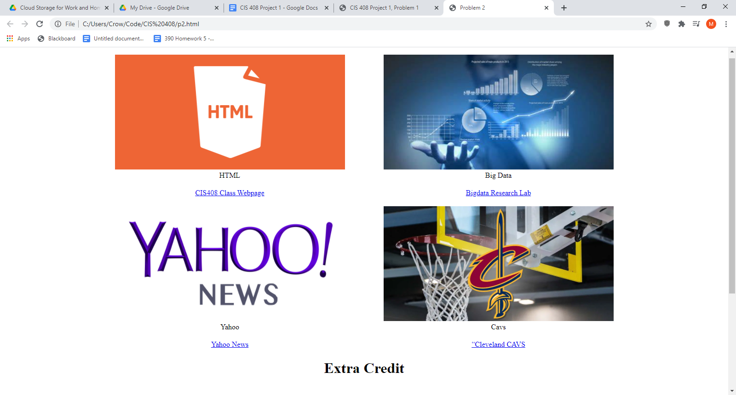

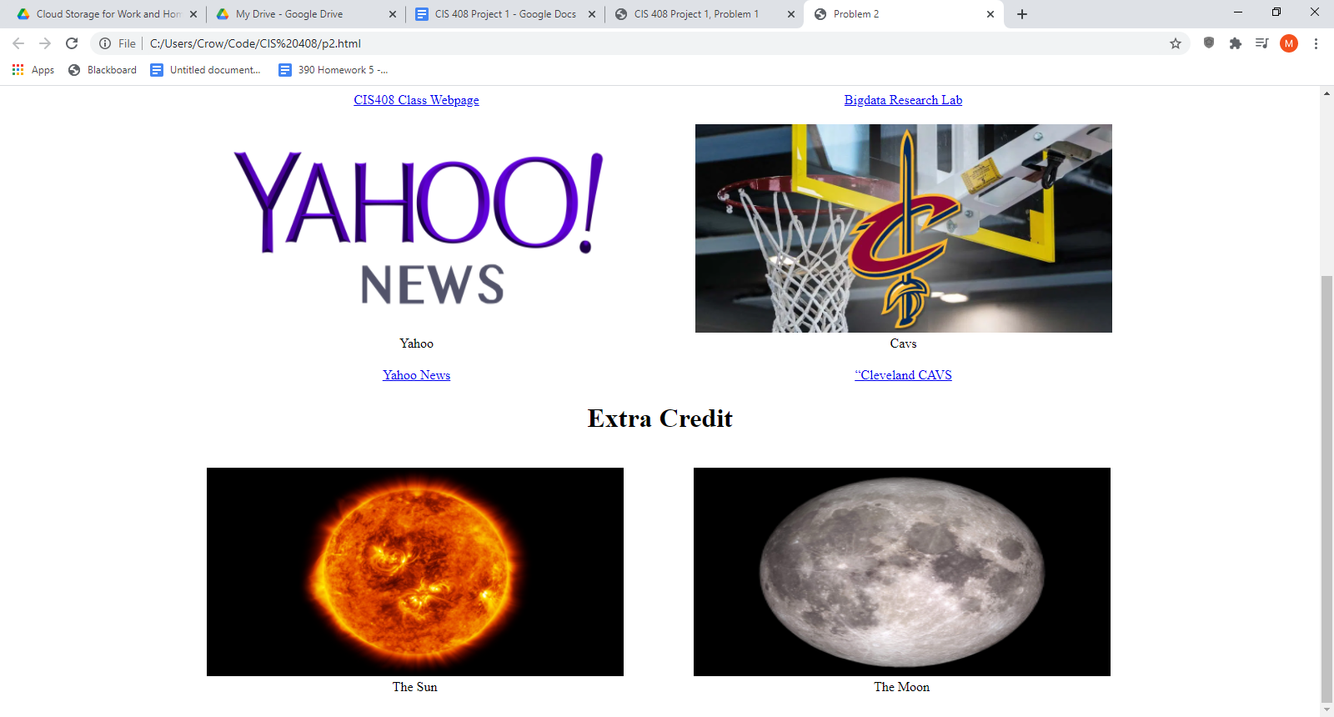

<?xml version="1.0" encoding="UTF-8"?>

<!DOCTYPE html PUBLIC "-//W3C//DTD XHTML 1.1//EN"

"http://www.w3.org/TR/xhtml11/DTD/xhtml11.dtd">

<html xmlns="http://www.w3.org/1999/xhtml">

<head>

<title>Problem 2</title>

<style>

td, h1 {text-align: center;}

table {margin: auto;}

</style>

</head>

<body>

<div>

<table>

<tr>

<td>

<figure>

<img src="https://www.bestwebsitebuilders.uk/wp-content/uploads/2018/06/html-1080x500.png" alt="HTML logo" style="width: 500px; height: 250px;" />

<figcaption>HTML</figcaption>

</figure>

</td>

<td>

<figure>

<img src="https://th.bing.com/th/id/OIP.IpLnvw8ihPDUeHthHIGddgHaEj?pid=Api&rs=1" alt="Man conjuring graphs" style="width: 500px; height: 250px;" />

<figcaption>Big Data</figcaption>

</figure>

</td>

</tr>

<tr>

<td><a href="http://cis.csuohio.edu/~sschung/CIS408/CIS408S21.html">CIS408 Class Webpage</a></td>

<td><a href="http://cis.csuohio.edu/~sschung/">Bigdata Research Lab</a></td>

</tr>

<tr>

<td>

<figure>

<img src="https://upload.wikimedia.org/wikipedia/commons/thumb/5/5f/Yahoo!News_Logo.svg/1200px-Yahoo!News_Logo.svg.png" alt="Yahoo news logo" style="width: 500px; height: 250px;" />

<figcaption>Yahoo</figcaption>

</figure>

</td>

<td>

<figure>

<img src="https://www.wkbn.com/wp-content/uploads/sites/48/2019/06/cleveland-cavaliers-basketball-generic-4.jpg?w=960&h=540&crop=1" alt=Cavs logo" style="width: 500px; height: 250px;" />

<figcaption>Cavs</figcaption>

</figure>

</td>

</tr>

<tr>

<td><a href="https://news.yahoo.com/">Yahoo News</a></td>

<td><a href="https://www.nba.com/cavaliers/">“Cleveland CAVS</a></td>

</tr>

</table>

</div>

<div>

<h1>Extra Credit</h1>

<table>

<tr>

<td>

<figure>

<img src="https://d2r55xnwy6nx47.cloudfront.net/uploads/2018/07/SolarFull_SeanDoran_2880FullwidthLede.jpg" alt="The Sun" style="width: 500px; height: 250px;" />

<figcaption>The Sun</figcaption>

</figure>

</td>

<td>

<figure>

<img src="https://scitechdaily.com/images/Lunar-Reconnaissance-Orbiter-Moon-scaled.jpg" alt="The moon" style="width: 500px; height: 250px;" />

<figcaption>The Moon</figcaption>

</figure>

<td>

</tr>

</table>

</div>

</body>

</html>

**Problem 3**

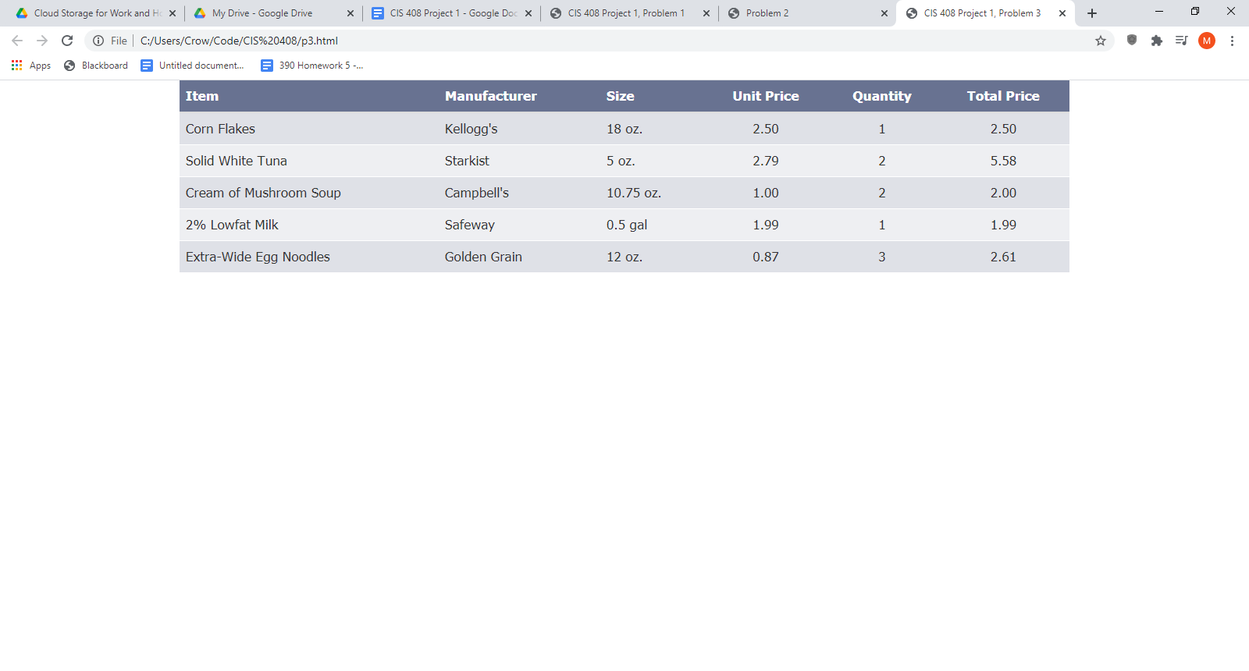

**A version**

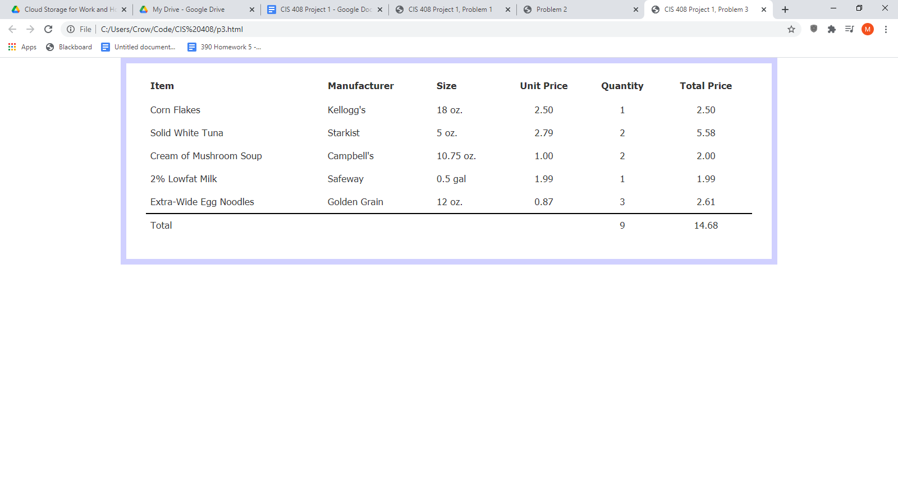

**B version**

**P3.html**

<?xml version="1.0" encoding="UTF-8"?>

<!DOCTYPE html PUBLIC "-//W3C//DTD XHTML 1.1//EN"

"http://www.w3.org/TR/xhtml11/DTD/xhtml11.dtd">

<html xmlns="http://www.w3.org/1999/xhtml">

<head>

<meta name="viewport" content="width=device-width, initial-scale=1" />

<link rel="stylesheet" type="text/css" href="p3a.css" />

<link rel="stylesheet" href="https://maxcdn.bootstrapcdn.com/bootstrap/3.4.1/css/bootstrap.min.css" />

<script type="text/javascript" src="https://ajax.googleapis.com/ajax/libs/jquery/3.5.1/jquery.min.js"></script>

<script type="text/javascript" src="https://maxcdn.bootstrapcdn.com/bootstrap/3.4.1/js/bootstrap.min.js"></script>

<title>CIS 408 Project 1, Problem 3</title>

</head>

<body>

<div class="container table-responsive">

<table cellspacing="0" class="table">

<thead>

<tr>

<th>Item</th>

<th>Manufacturer</th>

<th>Size</th>

<th>Unit Price</th>

<th>Quantity</th>

<th>Total Price</th>

</tr>

</thead>

<tbody>

<tr>

<td>Corn Flakes</td>

<td>Kellogg's</td>

<td>18 oz.</td>

<td>2.50</td>

<td>1</td>

<td>2.50</td>

</tr>

<tr>

<td>Solid White Tuna</td>

<td>Starkist</td>

<td>5 oz.</td>

<td>2.79</td>

<td>2</td>

<td>5.58</td>

</tr>

<tr>

<td>Cream of Mushroom Soup</td>

<td>Campbell's</td>

<td>10.75 oz.</td>

<td>1.00</td>

<td>2</td>

<td>2.00</td>

</tr>

<tr>

<td>2% Lowfat Milk</td>

<td>Safeway</td>

<td>0.5 gal</td>

<td>1.99</td>

<td>1</td>

<td>1.99</td>

</tr>

<tr>

<td>Extra-Wide Egg Noodles</td>

<td>Golden Grain</td>

<td>12 oz.</td>

<td>0.87</td>

<td>3</td>

<td>2.61</td>

</tr>

<tr class="omit">

<td>Total</td>

<td></td>

<td></td>

<td></td>

<td>9</td>

<td>14.68</td>

</tr>

</tbody>

</table>

</div>

</body>

</html>

**p3a.css**

div {

font-family: Tahoma;

font-size: 13pt;

;

}

thead {

border-bottom: 1px solid white;

background-color: #687291;

color: white;

}

td{

border-bottom: 1px solid white;

}

td:nth-child(n+4), th:nth-child(n+4){

text-align: center;

}

tbody tr:nth-child(even) {

background-color: #eeeff2;

}

tbody tr:nth-child(odd) {

background-color: #dfe1e7;

}

.omit {

display: none;

}

**p3b.css**

div {

font-family: Tahoma;

font-size: 13pt;

}

.container {

border: 10px solid #d0d0ff;

}

table {

border: 20px solid white;

}

thead {

border-bottom: 3px solid white;

}

td {

border-bottom: 1px solid white;

}

tr:nth-last-child(2) td {

border-bottom: 2px solid black;

}

td:nth-child(n+4), th:nth-child(n+4){

text-align: center;

}

**Problem 4**

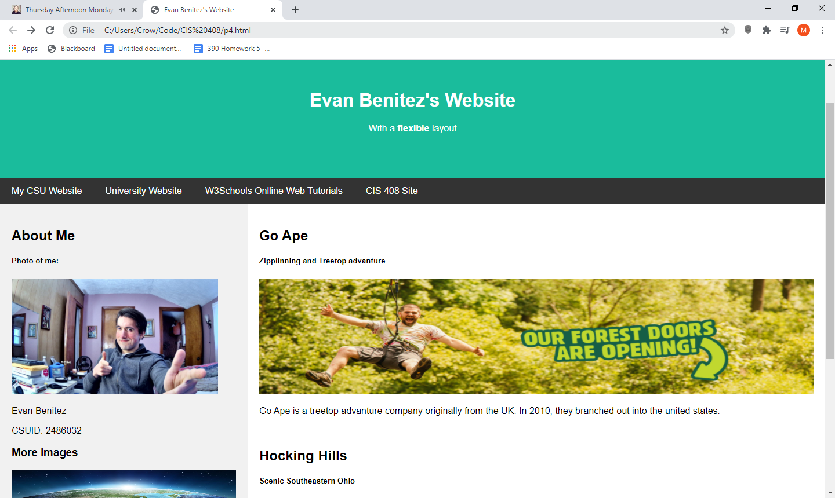

Full size

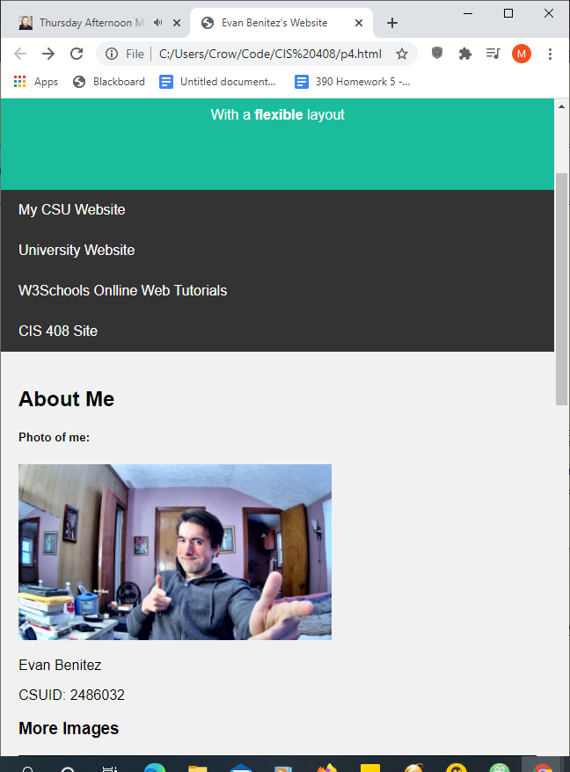

Reduced width view

<?xml version="1.0" encoding="UTF-8"?>

<!DOCTYPE html PUBLIC "-//W3C//DTD XHTML 1.1//EN"

"http://www.w3.org/TR/xhtml11/DTD/xhtml11.dtd">

<html xmlns="http://www.w3.org/1999/xhtml">

<head>

<title>Evan Benitez's Website</title>

<meta name="viewport" content="width=device-width, intial-scale=1" />

<style type="text/css">

/* style elements Copied from W3school.com */

* {

box-sizing: border-box;

}

/* body style */

body {

font-family: Arial;

margin: 0;

}

/* Header and logo Tile */

.header {

padding: 60px;

text-align: center;

background: #1abc9c;

color: white;

}

/* Style the top navigation bar */

.navbar {

display: flex;

background-color: #333;

}

/* Style the navigation bar links */

.navbar a {

color: white;

padding: 14px 20px;

text-decoration: none;

}

/* Change color on hover */

.navbar a:hover {

background-color: #ddd;

color: black;

}

/* Column container */

.row {

display: flex;

flex-wrap: wrap;

}

/* Create two unequal columns that sits next to each other */

.side {

flex: 30%;

background-color: #f1f1f1;

padding: 20px;

}

/* Main column */

.main {

flex: 70%;

background-color: white;

padding: 20px;

}

/* footer */

.footer {

padding: 20px;

text-align: center;

background: #ddd;

}

/* Responsive layout */

@media (max-width: 700px) {

.row, .navbar {

flex-direction: column;

}

}

</style>

</head>

<body>

<div style="background: yellow; padding: 5px;">

<h4 style="text-align: center;">Resize the browser window to see the responsive effect.</h4>

</div>

<div class="header">

<h1>Evan Benitez's Website</h1>

<p>With a <b>flexible</b> layout</p>

</div>

<div class="navbar">

<a href="http://eecs.csuohio.edu/~evbenite/">My CSU Website</a>

<a href="https://www.csuohio.edu/">University Website</a>

<a href="https://www.w3schools.com/">W3Schools Onlline Web Tutorials</a>

<a href="http://eecs.csuohio.edu/~sschung/CIS408/CIS408S21.html#Lab">CIS 408 Site</a>

</div>

<div class="row">

<div class="side">

<h2>About Me</h2>

<h5>Photo of me:</h5>

<img src="http://eecs.csuohio.edu/~evbenite/Pic.jpg" alt="Evan Benitez" style="height: 200px;" />

<p>Evan Benitez</p>

<p>CSUID: 2486032</p>

<h3>More Images</h3>

<div><img src="https://woub.org/wp-content/uploads/2015/04/earth-hi-res.jpg" alt="Earth" style="height: 60px; width:100%" /></div><br />

<div><img src="https://irp-cdn.multiscreensite.com/159d259b/dms3rep/multi/trees-blowing-in-the-wind-that-may-damage-your-roof.jpg" alt="Trees Blowing" style="height: 60px; width:100%" /></div><br />

<div><img src="https://media.pri.org/s3fs-public/styles/story_main/public/story/images/FIRE-CaliforniaFire.jpg?itok=PYQ8roFw" alt="Fire" style="height: 60px; width:100%" /></div>

</div>

<div class="main">

<h2>Go Ape</h2>

<h5>Zipplinning and Treetop advanture</h5>

<img src="https://www.goape.com/wp-content/uploads/2021/02/forest-doors-opening-1536x474.jpg" alt="Guy zipplining" style="height: 200px; width:100%" />

<p>Go Ape is a treetop advanture company originally from the UK. In 2010, they branched out into the united states.</p>

<br />

<h2>Hocking Hills</h2>

<h5>Scenic Southeastern Ohio </h5>

<img src="https://innatcedarfalls.com/wp-content/uploads/2017/02/hocking-hils-state-park-ohio-1500x609.jpg" alt="Waterfall" style="height: 200px; width:100%" />

<p>Located in Southeastern Ohio, the Hocking Hill offer picturesque landscapes and scenery.</p>

</div>

</div>

<div class="footer">

<h2>Footer</h2>

</div>

</body>

</html>

**SInce the pictures in the right pain are rather wide, the contents will actually stack before the width is below 700px. The links however, will stack when 700px is hit.**